Report: Order Delivery Time Prediction

Objectives
The objective of this assignment is to build a regression model that predicts the delivery time for orders placed through Porter. The model will use various features such as the items ordered, the restaurant location, the order protocol, and the availability of delivery partners.
The key goals are:
- Predict the delivery time for an order based on multiple input features
- Improve delivery time predictions to optimize operational efficiency
- Understand the key factors influencing delivery time to enhance the model's accuracy

Data Preparation
  - Loading the dataset
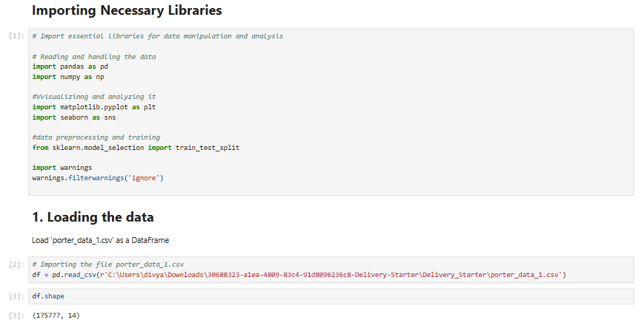

Data Preprocessing and Feature Engineering:

2.1 Fixing the Datatypes
    - Convert date and time fields to appropriate data type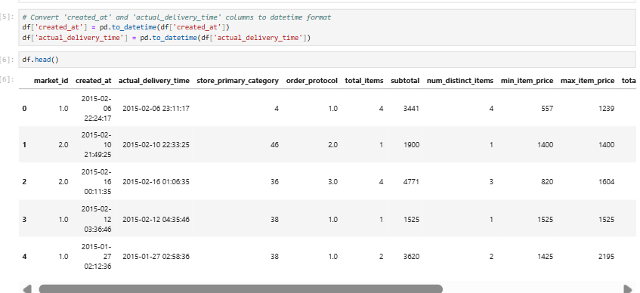
    - Convert categorical fields to appropriate data type
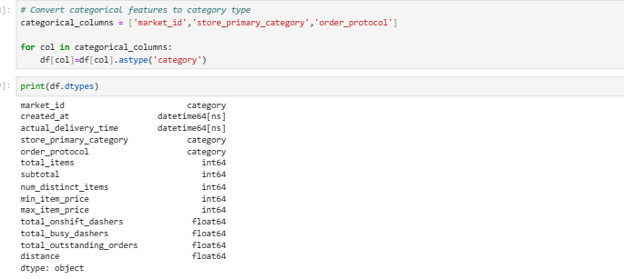

Feature Engineering
    - Calculate the time taken using the features actual_delivery_time and created_at
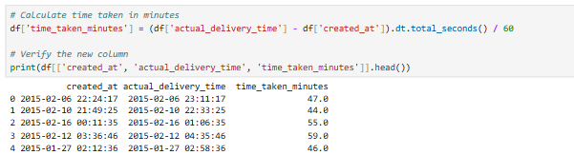
    - Extract the hour at which the order was placed and which day of the week it was. Drop the unnecessary columns.
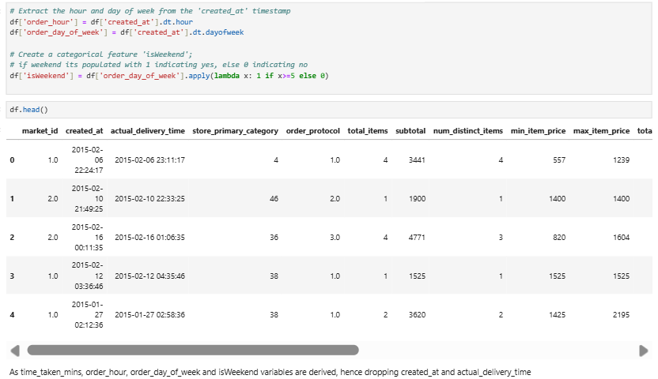

Creating training and validation sets
    - Define target and input features
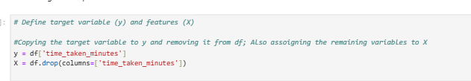
    - Split the data into training and test sets
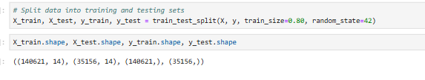

Exploratory Data Analysis on Training Data

Feature Distribution
    - Plot distributions for numerical columns in the training set to understand their spread and any skewness
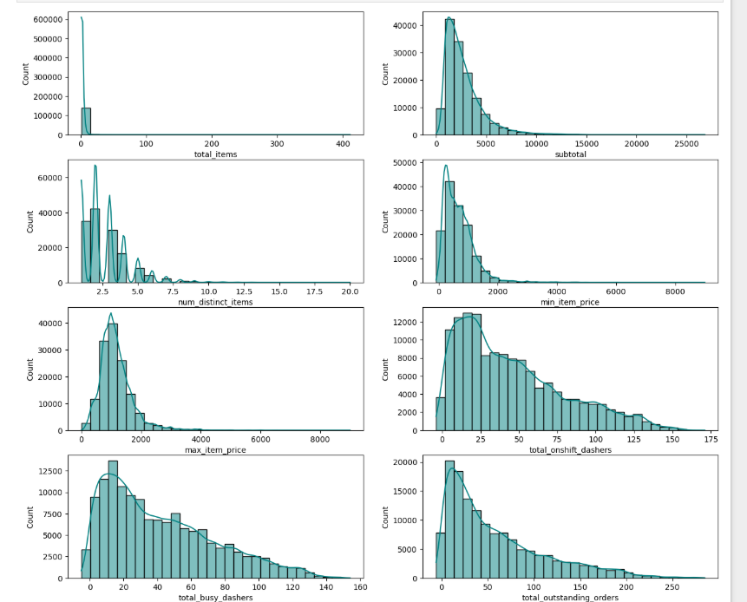
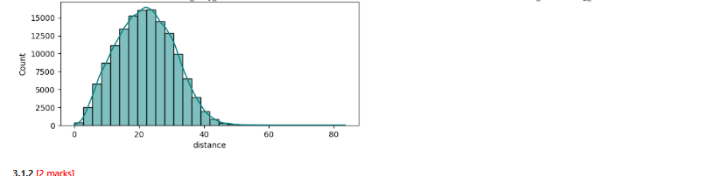
    - Check the distribution of categorical features
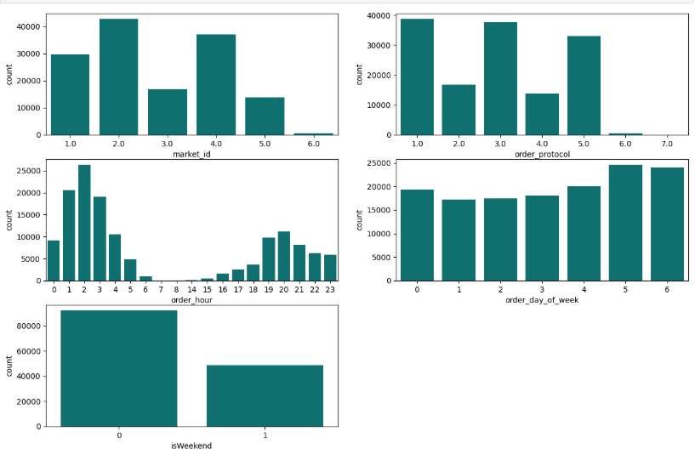
    - Visualize the distribution of the target variable to understand its spread and any skewness
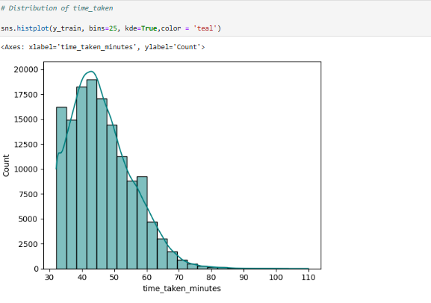

Relationships Between Features

    - Scatter plots for important numerical and categorical features to observe how they relate to time_taken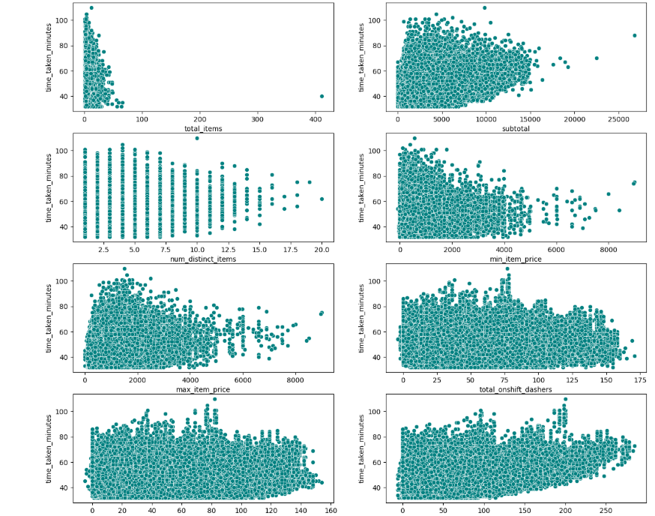
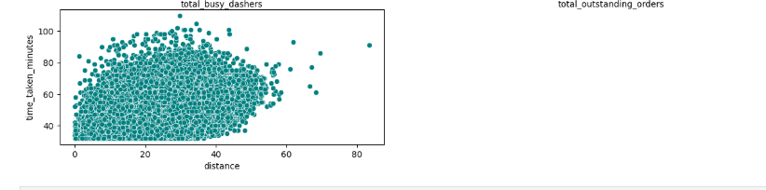
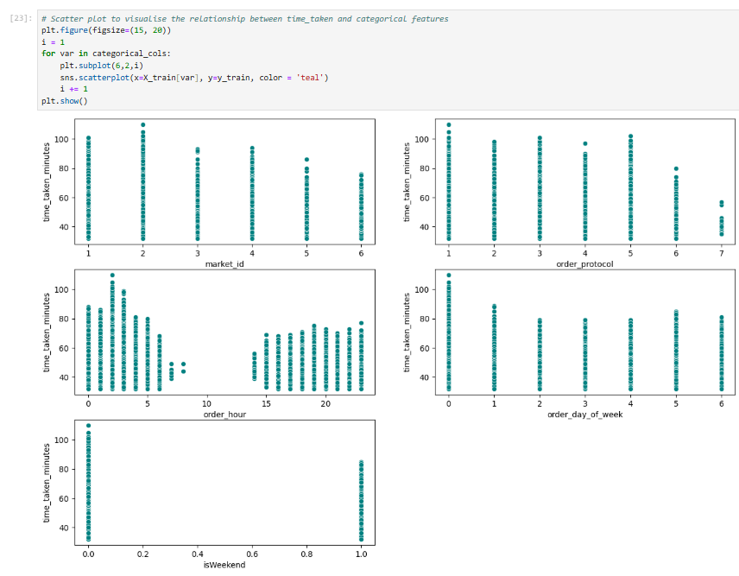
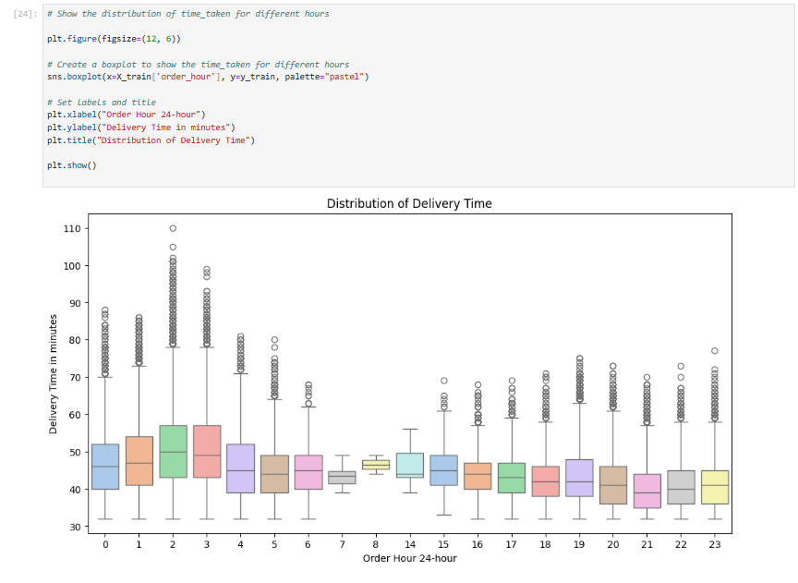
3.3 Correlation Analysis
3.3.1 Plot a heatmap to display correlations
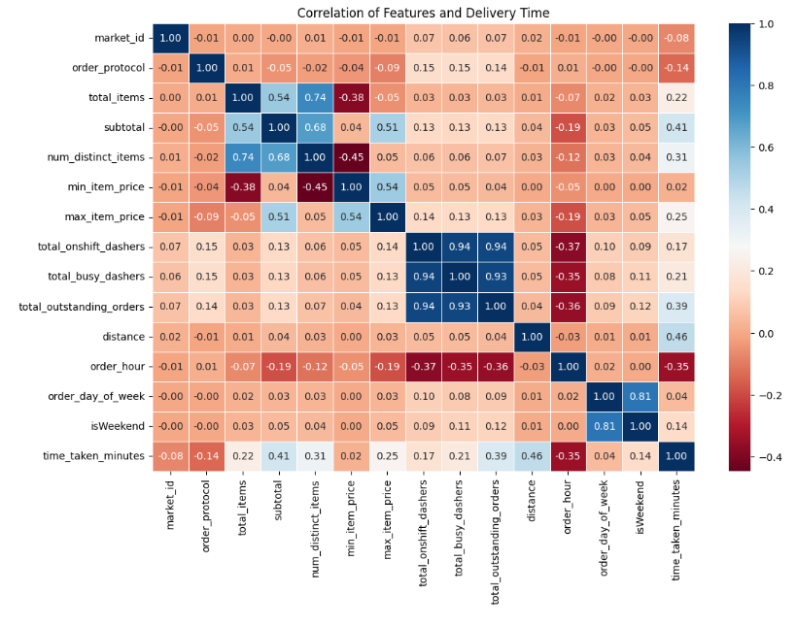
3.3.2 Drop the columns with weak correlations with the target variable
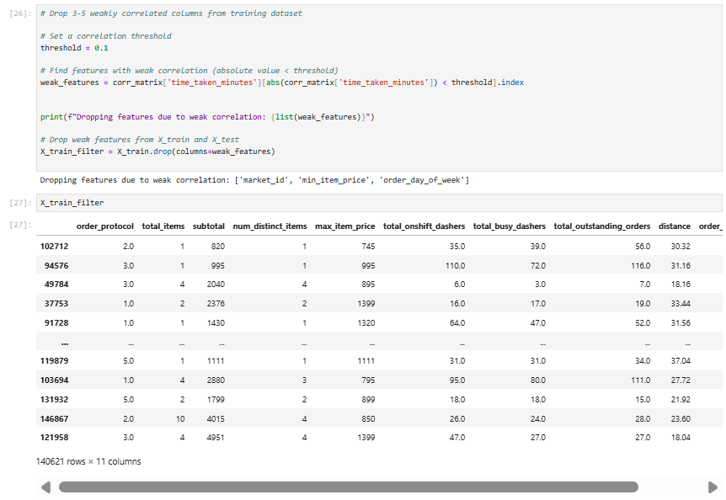
3.4 Handling the Outliers
3.4.1 Visualize potential outliers for the target variable and other numerical features using boxplots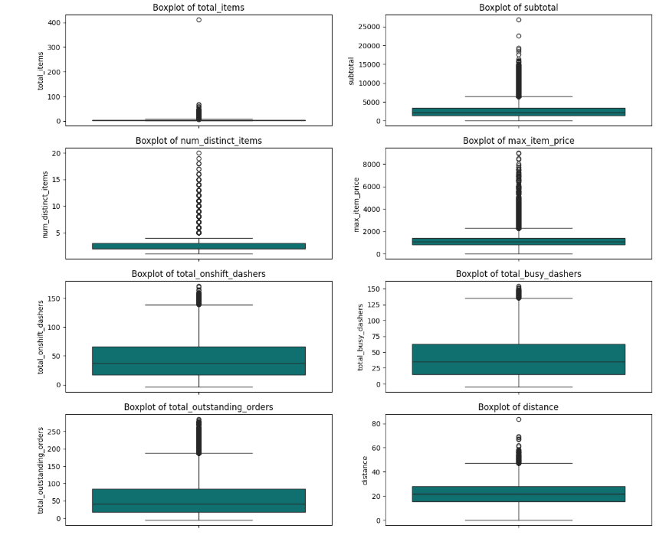
3.4.2 Handle outliers present in all columns
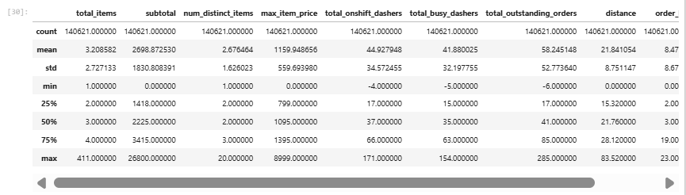
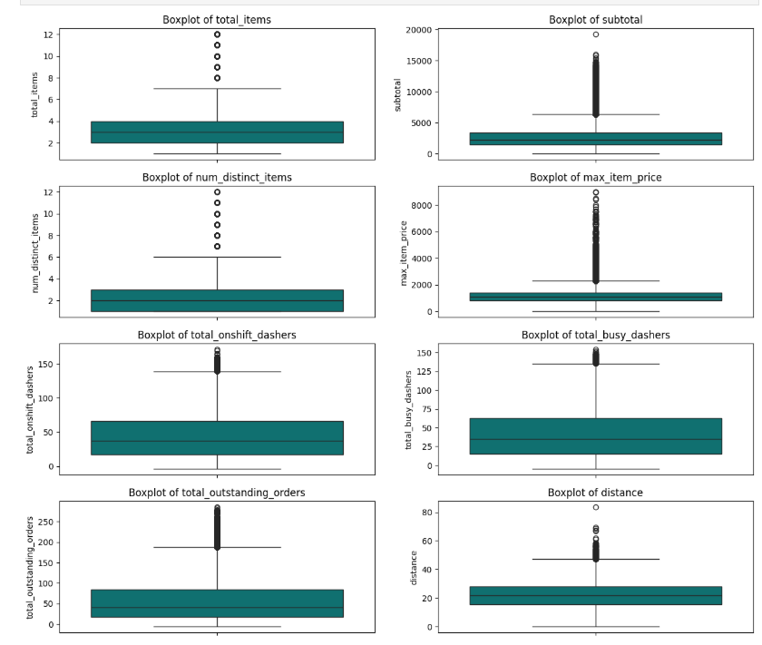
After Outlier Removal:
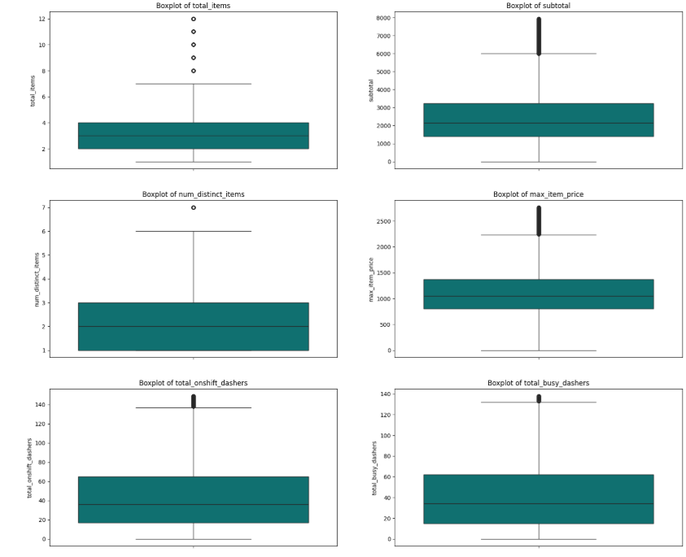
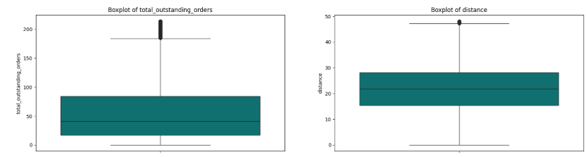

Exploratory Data Analysis on Validation Data
4.1 Feature Distributions
4.1.1 Plot distributions for numerical columns in the validation set to understand their spread and any skewness
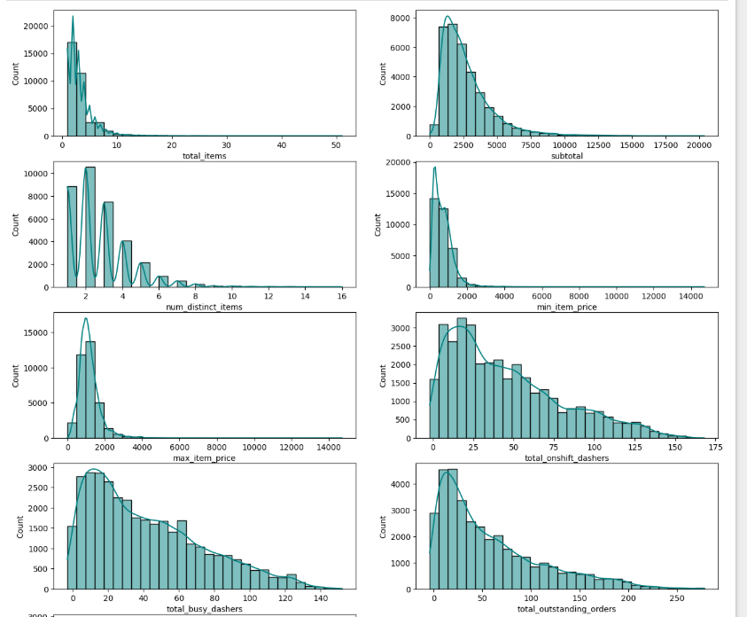
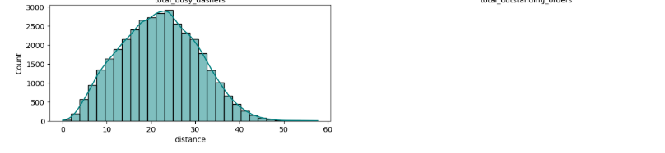
4.1.2
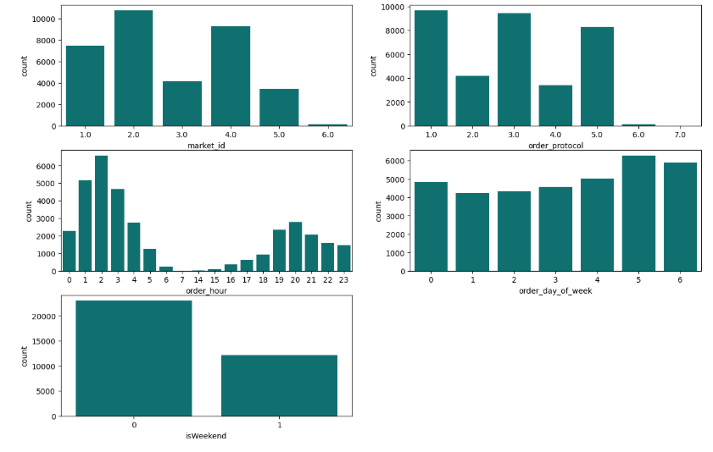
4.1.3 Visualize the distribution of the target variable to understand its spread and any skewness
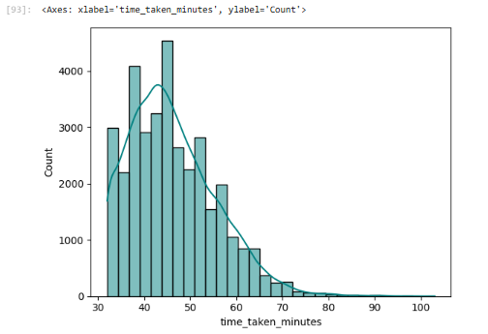
4.2 Relationships Between Features
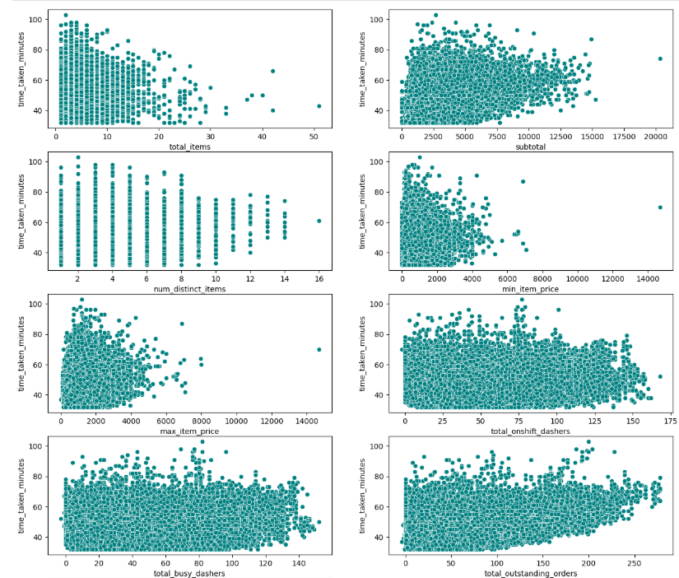
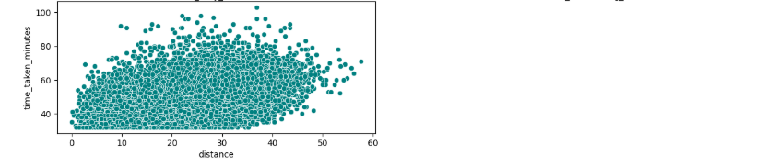

4.3 Drop the columns with weak correlations with the target variable
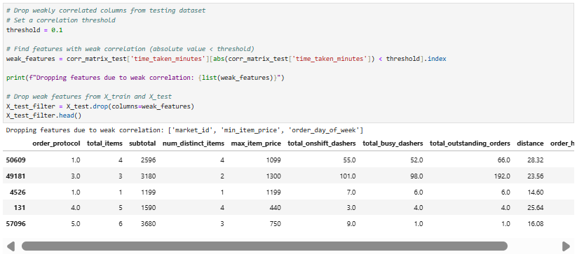

Model Building

Feature Scaling
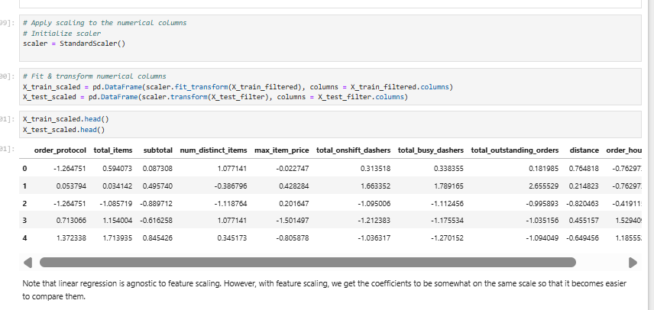

Build a linear regression model
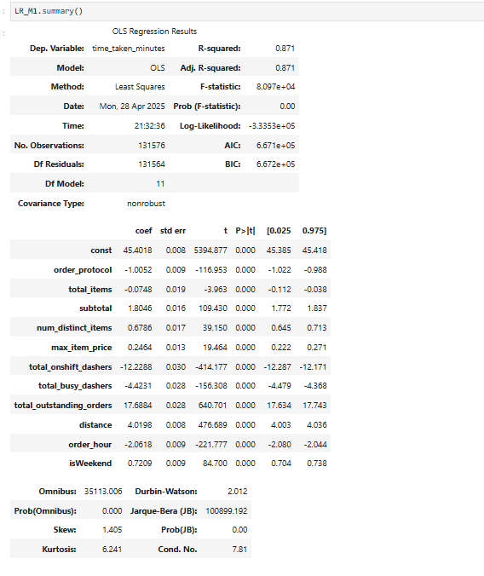
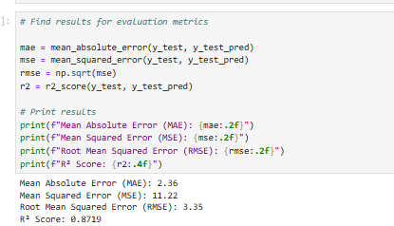

  - Build the model and fit RFE to select the most important features
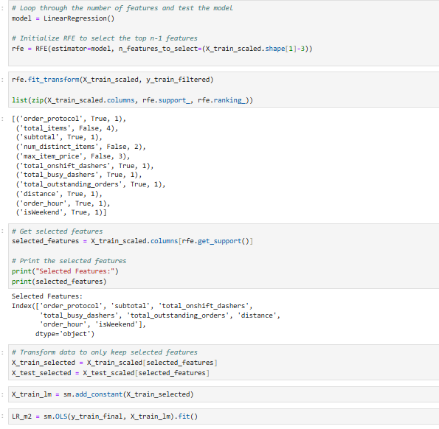
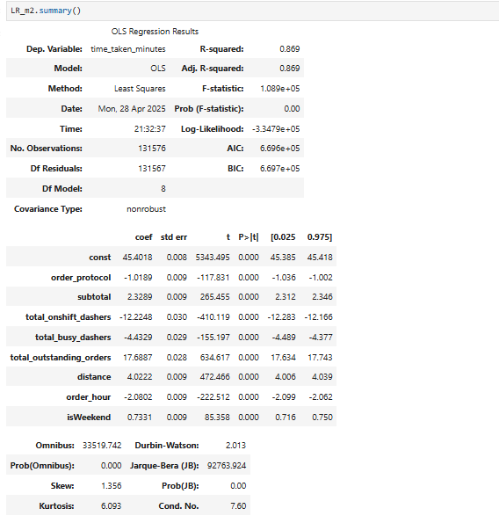
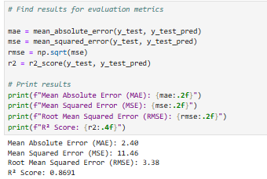

- Results and Inferences
6.1 Perform Residual Analysis
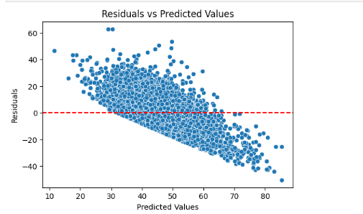
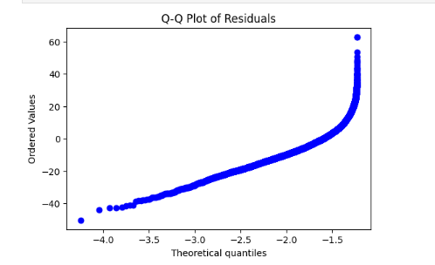
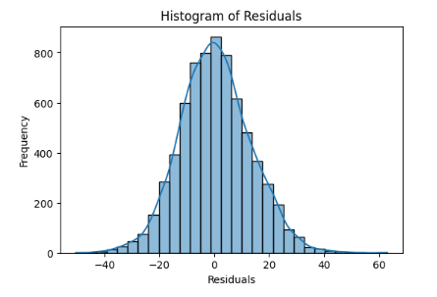
6.2 Perform Coefficient Analysis
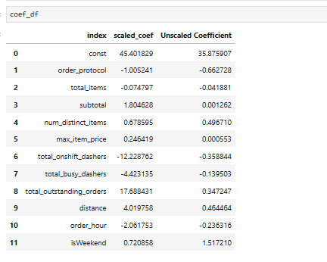
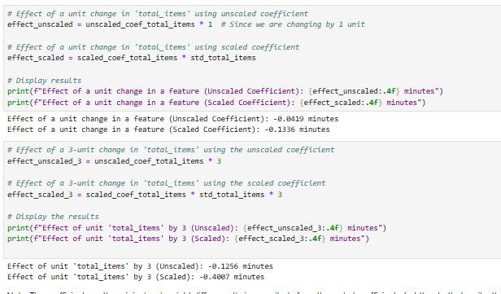

Subjective Questions
Question 1. [2 marks]
Are there any categorical variables in the data? From your analysis of the categorical variables from the dataset, what could you infer about their effect on the dependent variable?

Answer: Yes, there are categorical variables in the dataset.
From the dataset exploration and preprocessing steps in the notebook, the following categorical columns were found:

store_primary_category
market_id
order_protocol
isWeekend

Question 2. [1 marks]
What does test_size = 0.2 refer to during splitting the data into training and test sets?
Answer: The test_size = 0.2 refers to the proportion of the dataset that will be allocated to the test set when splitting the data into training and test sets. In this case, it means that 20% of the data will be used for testing the model, while the remaining 80% will be used for training the model.

Question 3. [1 marks]
Looking at the heatmap, which one has the highest correlation with the target variable?

Answer: Looking at the heatmap, variable distance has the highest (i.e. 0.46) positive correlation with target variable delivery_time_minutes. This means that with increase in distance the delivery time also increases.

Question 4. [2 marks]
What was your approach to detect the outliers? How did you address them?

Answer:
Approach to Detect Outliers:

Visual Inspection:
Used boxplots to visualize numerical features (e.g., distance, subtotal, min_item_price). Outliers appeared as points beyond whiskers (( Q1 - 1.5 \times IQR ), ( Q3 + 1.5 \times IQR )).

IQR Method (Statistical Approach)
Calculated IQR (( Q3 - Q1 )) and flagged values below ( Q1 - 1.5 \times IQR ) or above ( Q3 + 1.5 \times IQR ) as outliers.
Example: Identified outliers in subtotal and total_onshift_dashers (e.g., negative values).

Removal of Extreme Outliers
Dropped rows with invalid outliers (e.g., min_item_price < 0, total_onshift_dashers < 0), as they were <2% of data and likely errors.
Capped values at Maximum: Cappted the total_outstanding_orders at maximum

Capping Outliers:
Answer: Capped extreme but valid values (e.g., high distance) at IQR thresholds to reduce their impact on the regression model.

Question 5. [2 marks]
Based on the final model, which are the top 3 features significantly affecting the delivery time?

Answer:
total_outstanding_orders
total_onshift_dashers
total_busy_dashers

Question 6. [ 3 marks]
Explain the linear regression algorithm in detail
Answer: Linear Regression, a supervised learning technique, predicts a continuous target variable using one or more independent variables (features), aiming to find the best-fit line that reduces the error between actual and predicted values.
It is categorized into two types:
1. Simple Linear Regression:
○ Involves one dependent variable predicted by one independent variable.
○ The relationship is expressed as:
○ Y=mX+c Y = mX + c Y=mX+c
2. Multiple Linear Regression:
○ Involves one dependent variable predicted by several independent variables.
○ The relationship is modeled as:
○ Y=b0+b1X1+b2X2+…+bnXn Y
How Linear Regression Works:
1. Step 1: Identifying Variable Relationships
○ Assumes a linear relationship between the dependent variable Y and independent variables X , fitting a straight line to capture this trend.
2. Cost Function (Error Calculation)
○ Errors are computed by comparing predicted and actual values, typically using Mean Squared Error (MSE) as the error metric.
3. Optimization (Achieving the Best Fit)
○ Aims to minimize MSE by determining optimal coefficients, using methods like Gradient Descent or Ordinary Least Squares (OLS).
4. Model Assessment
○ Performance is evaluated with metrics such as:
○ Mean Absolute Error (MAE): Average of absolute differences.
○ Mean Squared Error (MSE): Emphasizes larger errors.
○ Root Mean Squared Error (RMSE): Interpretable error measure.
○ R² Score: Indicates the variance explained by the model.

Question 7. [2 marks]
Explain the difference between simple linear regression and multiple linear regression
Selection deleted

Answer: Simple Linear Regression involves one independent variable to predict a continuous dependent variable, using the equation Y=mX+c Y = mX + c Y=mX+c, where m is the slope and c is the intercept, capturing a single linear relationship. Multiple Linear Regression, however, uses multiple independent variables to predict the dependent variable, with the equation Y=b0+b1X1+b2X2+…+bnXn allowing it to model more complex relationships by considering the combined effect of several features.

Question 8. [2 marks]
What is the role of the cost function in linear regression, and how is it minimized?
Selection deleted

Answer: The cost function in linear regression, typically the Mean Squared Error, measures the average squared difference between predicted and actual values, quantifying the model's error. It is minimized by adjusting the model's coefficients using methods like Ordinary Least Squares, which finds the optimal values analytically, or Gradient Descent, which iteratively updates coefficients to reduce error until the best-fit line is achieved.

Question 9 [ 2 marks]
Explain the difference between overfitting and underfitting.

Answer: Overfitting occurs when a model learns the training data too well, capturing noise and specific patterns, leading to poor performance on new data due to excessive complexity. Underfitting happens when a model is too simple to capture the underlying patterns in the data, resulting in high errors on both training and test sets, as it fails to learn the relationships effectively.

Question 10. [3 marks]
How do residual plots help in diagnosing a linear regression model?

Answer: Residual plots help diagnose a linear regression model by showing the difference between actual and predicted values (residuals) against predicted values or features. If residuals are randomly scattered around zero with no clear pattern, the model fits well; however, patterns like curves or trends indicate issues like non-linearity or heteroscedasticity, suggesting the model needs adjustments.

